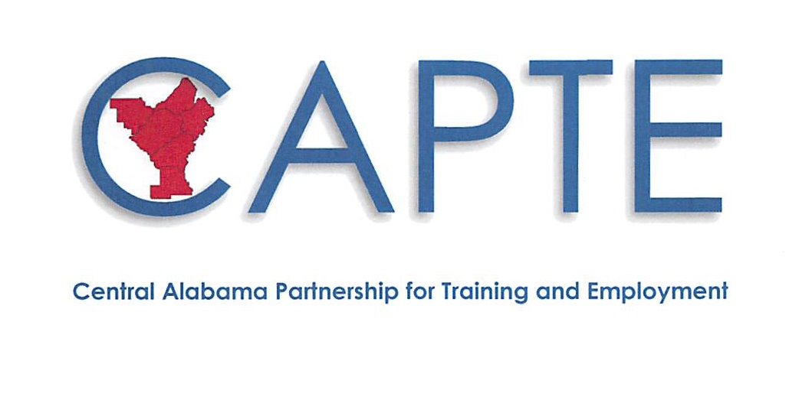

**Local Workforce Development Area 4 Plan**

**2017-2021**

**Central Alabama Partnership for Training**

**and Employment (CAPTE)**

**I. Local Area Governance**

**a. Provide the most current organizational chart depicting the relationship of the agencies comprising the workforce system, including education, economic development, and the one-stop delivery system partners.**

**(See Attachment 1)**

***In order for any agreement for CAPTE to become legally binding, it has to be approved by the Jefferson County Commission. Jimmie Stephens is the President of the Jefferson County Commission and has the authority to sign legal documents receiving federal funds for the CAPTE and the Local Workforce Area 4.***

***The County Manager reviews all contracts and agreements before they are placed on the Commission Agenda for consideration. He is also responsible for all departments within Jefferson County government.***

***The CAPTE Workforce Development Local Board consists of approximately thirty-one individuals that meet, or exceed, the required membership criteria.***

***The Jefferson County Department of Human-Services and Economic Development serves as the operational unit that administers the workforce development agreement in Jefferson County.***

***The Alabama Career Center is the point of entry for public access to the services offered through workforce development programs.***

**b. Identify the entity responsible for the disbursal of grant funds, as determined by the chief elected official or the Governor (20 CFR 679.560(b)(14)). Identify by name, function, and organizational affiliation of the local area:**

|  |  |  |
| --- | --- | --- |
| **Name** | **Function** | **Affiliation** |
| **Commissioner James A. Stephens** | **Chief Elected and Signatory Official for Jefferson County** | **Commission President** |
|  |  |  |
|  |  |  |
|  |  |  |
|  |  |  |

**II.**

**Local Workforce Development Board**

a. Provide a current listing of local board membership, including the category of representation as outlined in WIOA sec. 107(b)(2). The board must include:

1. Business Representatives — majority of members
2. Workforce Representatives — at least twenty percent, and must include:

Representatives of labor organizations (for a local area in which employees are represented by labor organizations), who have been nominated by local labor federations, or (for a local area in which no employees are represented by such organizations) other representative of employees.

A representative of a labor organization or a training director, from a joint labor-management apprenticeship program, or if no such joint program exists in the area, such a representative of an apprenticeship program, if such a program exists.

1. Education and Training Activities Representatives.
2. Governmental & Economic and Community Development Representatives.

**Central Alabama Partnership for Training and Employment**

**Workforce Development Board**

**Businesses Representatives**

**WIOA Section 107(b)(2)(A)- a majority of the members shall be representatives of business in the local area and must include (i) owners of businesses, chief executives or operating officers of businesses, and other business executives or employers with optimum policy-making or hiring authority; (ii) representatives of business, including small businesses, or organizations; (iii) appointed from among individuals nominated by local business organizations and business trade associations. Please identify the local board chairperson in the first blank with the asterisk.**

|  |  |  |  |
| --- | --- | --- | --- |
| Name | | Title | Entity |
| 1* | John Beard | Chairman & President | Alacare Home Health & Hospice |
| 2 | Lynn Battle | Vice President | Phoenix Development |
| 3 | Willie Chriesman | Chief Executive Officer | Chriesman & Associates |
| 4 | Kristie Rankin | President | Abstract |
| 5 | Dr. Thomas Ellison | Executive Director | Project H.E.L.P. USA |
| 6 | Nolanda Hatcher-Bearden | Managing Partner | Studio 2H Design, LLC |
| 7 | Flora Hollis-Williams | Human Resources Manager | Sterilite Corporation |
| 8 | Melva Tate | President | Tate & Associates |
| 9 | Walter Turner | Director | School Transportation Solutions |
| 10 | L’Tryce Slade | Owner | Slade Environmental & Consulting |
| 11 | Jarrod Sims | President & CEO | SYMS Contractors, Inc. |
| 12 | Jay Reed | President | Associated Builders and Contractors, Inc. |
| 13 | John Hackett | General Manager | Kamtek, Inc. |
| 14 | Frank Topping | Chief Development Officer | AJK&B Managers, Consultants & Developers |
| 15 | Jason Goodgame | Vice President | Goodgame Company, Inc. |
| 16 | Rich Metcalf | Plant Director | Gestamp Alabama, Inc. |
| 17 | Garth Thorpe | Workforce Development Mgr. | The Onin Group |
| 18 | Kirk Mancer | President and CEO | Shelby County Chamber |
| 19 | Lisa Nichols | Administrator | St. Vincent’s St. Clair Hospital |
| 20 | David Hornsby | Owner | Hornsby Steel |
| 21 | Kassidy Anderson | Human Resource Manager | Central States Manufacturing |
| 22 | Sharon Becker | Human Resources | Yorozu Automotive Alabama |
| 23 | Joseph Parnell | Manager | Parnell, Inc. |

*\*Board Chair*

**Workforce Representatives:**

**WIOA Section 107(b)(2)(B)- Not less than 20% of the members must be representatives of workforce within the local area that include: (i) representatives from labor organizations who have been nominated by local labor federations; (ii) a member from a joint labor- management apprenticeship program, or if no such joint program exists in the area, such a representative of an apprenticeship program in the area; and may include: (iii) representatives from community based organizations with demonstrated experience and expertise in addressing the employment needs of individuals with barriers to employment, veterans, or individuals with disabilities; and (iv) representatives of organizations with demonstrated experience and expertise in addressing the employment, training, or education needs of eligible youth and/or out-of-school youth.**

|  |  |  |  |
| --- | --- | --- | --- |
| Name | | Title | Entity |
| 1 | Bill Blackmon | Business Manager | IBEW Local 136 |
| 2 | Brian Duncan | Business Manager | SMART Local 48 |
| 3 | Matthew Dudley | Training Director | Birmingham Electrical JATC |
| 4 | Mary Allbritten | Project Director | Alabama AFL-CIO Labor Institute for Training |
| 5 | Allen Howell | Business Manager | Int. Assoc. of Heat and Frost Insulators and Allied Workers |
| 6 | John Stamps | Director of Operations | Salvation Army |
| 7 | David Higgins | Executive Director | Easter Seals Birmingham  Area |
| 8 | Ben Hamm | Assistant Business Manager | Operating Engineers Local 312 |
| 9 | Fred Maddox | Business Manager | Iron Workers Local 92 |

**Education and Training Activities Representatives:**

**WIOA Section 117(b)(2)(C) - each local board shall include representatives of entities administering education and training activities in the local area and must include (i) a representative of eligible providers administering Title II adult education and literacy activities; (ii) a representative of institutions of higher education providing workforce investment activities; and may include (iii) representatives of local educational agencies, and community-based organizations with demonstrated experience and expertise in addressing the education or training needs of individuals with barriers to employment.**

|  |  |  |  |
| --- | --- | --- | --- |
| Name | | Title | Entity |
| 1 | Dr. Perry Ward | President | Lawson State Community College |
| 2 | Keith Brown | Interim President | Jefferson State Community College |
| 3 | Phillip Cleveland | Director | Blount County Career Technical College |
| 4 | Wendy Roberts | Education Specialist | Alabama Community College System |

**Governmental and Economic and Community Development Representatives**

**WIOA Section 107(b)(2)(D) and (E)- each local board shall include representatives of governmental, economic, community development entities serving the local area must include (i) a representative of economic and community development entities; (ii) a representative from the state employment service office under the Wagner-Peyser Act; (iii) a representative of the Vocational Rehabilitation program; and may include (iv) representatives of agencies or entities administering programs serving the local area relating to transportation, housing, and public assistance; (v) representatives of philanthropic organizations serving the local area; and (E) individuals or representatives of entities as the chief elected official in the local area may determine to be appropriate.**

|  |  |  |  |
| --- | --- | --- | --- |
| Name | | Title | Entity |
| 1 | Sheila Tyson | Commissioner | Jefferson County Commission |
| 2 | Josh Carpenter | Director | Birmingham Mayor’s Office of Economic Development |
| 3 | Yvette Fields | Manager | Birmingham Career Center |
| 4 | Yolanda Spencer | Supervisor | Vocational Rehabilitation Service |
| 5 | Jacqueline White | Manager-JOBS Program. | Department of Human Resources |
| 6 | Christine Brown | Director | Clanton Conference and Performing Arts Center -  Jefferson State Community College |
| 7 | Ted Von Cannon | Executive Director | Jefferson County Development Authority |
| 8 | Jason Roberts | Assistant Director | St. Clair County EDC |
| 9 | Melody Whitten | Director of Development | 58 Inc. |

b. **If the local board has not been formed at the time of plan submission, or it needs membership changes to be in compliance, include a timeframe to become compliant and the process that will be used to meet the requirements for local boards included in WIOA sec. 107. This process must include notifying the state of the formation of or any changes to the board and providing a list following the guidelines in Section II.a. above.**

**III. Career Centers**

a. List the Comprehensive Career Centers and the Satellite Career Centers operating within the local area.

|  |
| --- |
| **Comprehensive Career Centers** |
| Alabaster |
| Birmingham |
| Jasper |
| Pell City |
| **Satellite Career Centers** |
| Jefferson State Community College |

1. **Identify which partners are represented in the Career Center:**

Career and Technical Education (Perkins), Community Services Block Grant, Indian and Native American Programs, HUD Employment and Training Programs, Job Corps, Local Veterans' Employment Representatives and Disabled Veterans' Outreach Program, National Farmworker Jobs Program, Senior Community Service

Employment Program, Temporary Assistance for Needy Families (TANF), Trade Adjustment Assistance Programs, Unemployment Compensation Programs, and YouthBuild.

1. **Provide the name, title, telephone number, and email address of principle Career Center contacts.**

|  |  |  |  |  |
| --- | --- | --- | --- | --- |
| Center or Site | Contact Person | Title | Telephone | Email |
| Alabama Department of Labor | Ruby Beezley | Area Manager | (334) 328-4796 | ruby.beezly@alcc.alabama.gov |
| Adult Education and GED | David Walters | Vice Chancellor | (334) 293-4561 | david.walters@dpe.edu |
| Alabama Department of Rehabilitation Services | James Myrick | Assistant Commissioner | (334) 293-7500 | james.myrick@rehab.alabama.gov |
| Jefferson County Department of Human –Community Services and Economic Development | Frederick Hamilton | Director | (205) 325-5785 | frederick.hamilton@jccal.org |

***Note: The state board will develop and review current statewide policies affecting the coordinated provision of services through the state's one-stop delivery system in accordance with WIOA Section 101(d)(6). When these policies are finalized, local areas will be provided with the policies, and if necessary, a modification to the local plans will be requested to incorporate any needed changes.***

**IV. Analysis of Local Area Conditions and Needs**

1. **Provide analysis of local area economic conditions including existing and emerging in-demand industry sectors and occupations (20 CFR 679.560(a)(1)(i)). Existing current analysis may be used if available and appropriate (20 CFR 679.560(a)(1)(iii)).**

**THE ECONOMIC CONDITIONS FOR THIS REGION HAS NOT CHANGED DRAMATICALLY SINCE THE SUBMISSION OF THE INITIAL PLAN**.

This region primarily consists of the Birmingham-Hoover metropolitan area of Alabama, the largest metro area in the state. With a population over 1.1 million, the region represents 23% of the state’s population. Since 2010, the region has grown 1.8% in population, with Shelby County growing the most at 7.9% to 210,622. Walker County lost 3% of its population since 2010.

Nearly 26% of the state’s workforce is located in the region, with a total employment of 542,177 in 2014. This region is centrally located in the state with a six-spoke interstate system, which makes it a perfect location for regional distribution centers. The region is the financial center of the state, with approximately 50% of the state’s employment in finance and insurance industries. According to the Federal Reserve, Birmingham has nearly $220 billion in bank assets, ranking it as the second largest banking center in the south and 11th nationally. Corporate headquarters for four financial institutions and several major insurance companies are located here. The area also leads the state in health care services and research. The University of Alabama at Birmingham (UAB) is the fourth largest academic medical center in the United States, and it ranks 44th out of 965 institutions in the National Science Foundation Total R&D Expenditures. Furthermore, UAB’s University Hospital is the third largest public hospital in the nation. This region currently has the lowest unemployment rate in the state at 3.9%, with 20,447 unemployed.

The region has targeted five (5) industries for workforce development: Manufacturing, Healthcare, Energy, Services, and Logistics. It is important for these opportunities to exist, because in 2015-2016 over 2,000 people lost their jobs in the coal mining and steel industries.

|  |  |
| --- | --- |
| REGION 4 | |
| Existing In-Demand Industry Sectors | Occupations by Region |
| Target Industry Sectors | **Occupations** |
| * Manufacturing * Healthcare * Energy * Services * Logistics | * Welders/Fitters * Machinists * Industrial Maintenance * Nursing * Allied Health * Green Technology * IT * Customer Service * Culinary * Drivers |

In this area, unlike most other regions in the state, manufacturing is not the largest industry, with only 8% of total employment. Between 2011 and 2015, manufacturing employment grew over 6%. Unfortunately, as stated above, 2016 experienced huge losses in both coal mining and steel. Fortunately, there are automotive plants in close proximity, thus making the region a perfectly centered location for automotive suppliers. The industry has grown 19% since the recession and is sure to continue to grow with announcements already of nearly 700 new employees in the industry. In addition, plastics manufacturing has seen an increase in the last couple of years, as it is also vital to the automotive industry in the state. Since 2010, employment has grown over 12% in plastics manufacturing. The growth in these industries provides those high skilled steel workers great options for employment.

This region, known for its medical advancement, research, and expert care, contains some of the highest regarded healthcare in the state, as well as, in the country. Healthcare is the number one (1) industry in this region, consisting of 15% of the area’s employment. Employed in the healthcare industry alone are over 73,000 people. The largest growth over the recent years has been in offices of physicians. People travel from all over the state to consult with highly specialized physicians that do not exist in their local areas. As the population continues to age, healthcare will continue to grow at a steady pace to fulfill the needs of Alabamians.

Energy is a very large industry across the State of Alabama. According to a study published by the Energy Institute of Alabama, the state ranks in the top 10 in the country in largest coal exporting seaport, electricity generation from biomass, electricity generation, and electricity generation from renewable resources. It also ranks 16th in natural gas production. Although coal mining has taken a huge hit in the last couple of years, this region consists of approximately 33% of the state’s mining employment. Additionally, the area employs 44% of the state’s workers in utility industries. Employment in utilities has grown 26% since 2010.

Due to the large population in this area, the demand for services is huge. As the population grows and new industries locate in various parts of the region, services also grow. Since 2010, accommodations and food services employment has grown nearly 24%. Industries including caterers and mobile food have grown the most since 2010, at over 50%. Grocery Stores have finally made it to pre-recession employment levels, with over 8,000 employed. Since studies show that Alabama residents spend more dining out than buying groceries, the propensity for people to grab quick meals due to busy lives will continue to increase expectedly.

Logistics is a large industry in Region 4 because of its central location in the state and its ease of access to interstates and major highways. Since 2010, Warehousing employment has grown over 63% and Truck Transportation continues a steady upward trend growing 9.7%. Announcements for additional job growth in these industries are continuing to occur. The growth in these industries is one of the factors creating the huge demand for truck drivers. Exacerbating the issue is high turnover and a significant number of older truck drivers nearing retirement.

1. **Provide analysis of local area employment needs of employers in existing and emerging in-demand industry sectors and occupations (20 CFR 679.560(a)(1)(ii)). Existing current analysis may be used if available and appropriate (20 CFR 679.560(a)(1)(iii)).**

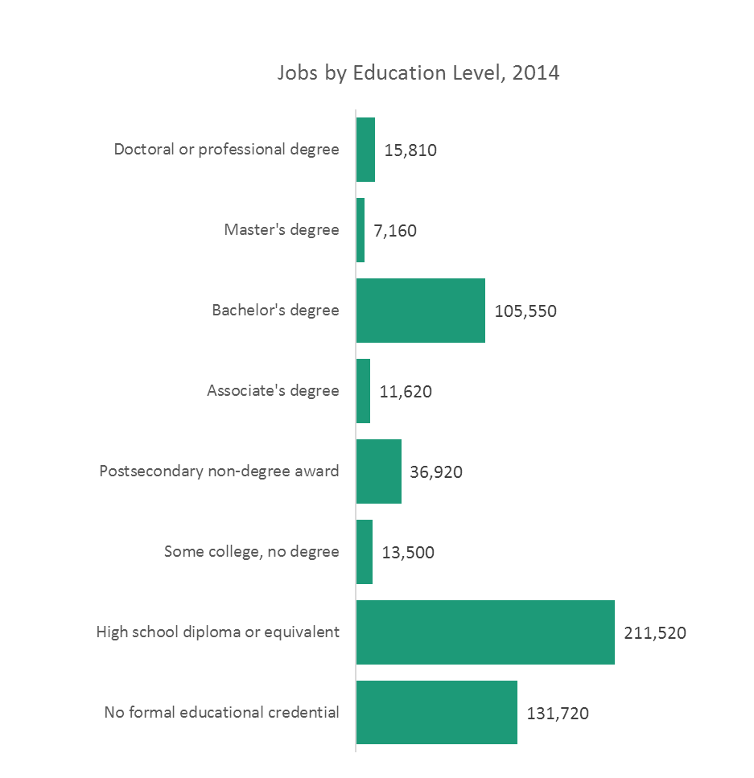In 2014, only 36% of jobs were in occupations that typically require postsecondary education for entry. Within this group, jobs in occupations, which require a Bachelor’s degree for entry, held the largest share at 55%. Occupations requiring a high school diploma or equivalent and less than high school made up 64% of jobs in 2014. Occupations with the highest percentage growth typically require a form of postsecondary education, with master’s degree occupations holding the highest share at 15.7%. The projected growth in occupations with a Master’s degree and Doctoral or professional degree in this region could be due to the number of healthcare, finance, and insurance professionals.

Projected to grow faster than the average for the Region, which is 6.9%, are all occupations requiring postsecondary education. Expected in occupations requiring some college, but no degree, is a slight drop at -0.1%. This category only covers four (4) occupations, one (1) of which is bookkeepers, which expectedly will drop over the period. Jobs in occupations requiring a high school diploma or equivalent and no formal educational credential should expectedly make up over half of the total projected jobs in this region at 64.3%. In this category, the leading occupations are retail salespersons, followed by Personal Care Aides, and Combined Food Preparation and Serving Workers, including Fast Food.

When categorized by On-the-Job Training (OJT), projections for occupations requiring an apprenticeship show the highest percentage of growth. Most apprenticeship occupations are from the construction and manufacturing industries. The top occupations requiring an apprenticeship with the highest numeric change in this region are electricians, carpenters, plumbers, pipefitters, and steamfitters.

1. **What knowledge and skills are needed to meet the employment needs of the employers in the local area, including employment needs in in-demand industry sectors and occupations ( 20 CFR 679.560(a)(2))?**

Over the past five (5) years, there has been a multitude of national reports on the topic of skills gaps. More importantly, the emphasis has been on soft skills. Alabama is no different. Employers around the state indicate that they cannot find employees with adequate skills. The Alabama Department of Labor, Labor Market Information Division conducted a skills survey to determine more specifically the problems that employers were experiencing. Many of the employers that expressed these concerns were in manufacturing and construction industries, so for this survey, the decision was made to survey employers in those two (2) industries, plus utilities. The Bureau of Labor Statistics randomly selected a sample of 6,926 employers. The survey, published in 2013, showed over 5,000 employers in the three industries responded.

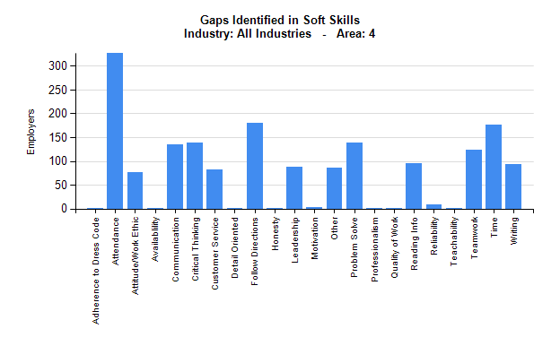

Over 300 employers in Region 4 indicated that the number one (1) reason for rejecting applicants was that they did not pass a drug screen, surpassing lack of work experience. When given the opportunity to list other reasons, employers indicated lack of driver’s license or reliable transportation; lack of required certification; attendance history; employment history; failed employment skills testing; and others, most relating to soft skills. A list of soft skills and a list of technical skills was provided, so the employers could choose all skills gaps that have been identified in existing staff. Of the soft skills, across all industries and all areas, attendance was the overwhelming top choice in the region. Others chosen at high levels were following directions, time management, and critical thinking. Gaps identified in technical skills often varied by industry. Transportation, Equipment, and Manufacturing companies reported the biggest technical skills gaps in welding and repairing. Utilities companies named math, engineering, and air conditioning as the top three (3) technical skills gaps they experience when hiring employees. Overall, the top five (5) technical skills gaps for the region were Machining, Electrical, Welding, Math/Other, and Engineering. When asked what area of training would be the most valuable to improve the workforce, choosing from soft skills, occupational experience, or education, the majority of employers ranked soft skills as most valuable.

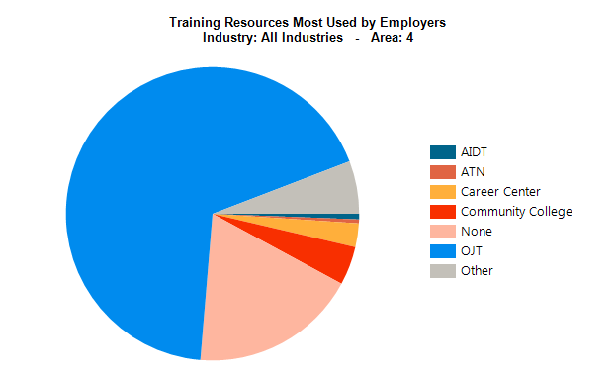

The survey revealed that in this Region, most employers in these industries do not presently use training resources offered by various workforce development partners. Most employers conduct their own On the Job Training. Of those companies that take advantage of outside training, most use community colleges or Career Centers. Furthermore, third party training courses (including online training) and Association Training were among the top resources identified by employers to train staff. In this Region, responses from Utilities companies indicated that 21% of them use community colleges for training their staff. Over 20% of manufacturers in electrical equipment, appliance, and components indicated that they use either career centers or community colleges to train employees.

1. **Provide an analysis of the local area's workforce, including current labor force employment and unemployment data, information on labor market trends, and educational and skill levels of the workforce, including individuals with barriers to employment 20 CFR 679.560(a)(3)).**

The unemployment rate has been declining continuously since 2009 when it was highest due to the recession. In 2016, the average annual unemployment rate for the region was 5.6%, ranging from 4.4% in Shelby County to 7.6% in Walker County. Per the American Community Survey, 2015 unemployment rates were higher for younger workers. Youth, age 16 to 19 experienced an estimated unemployment rate of 25.9% in 2015, which is down from 2011 when it was 27.1%. Labor Force participants between the ages of 20 and 24 experienced a decrease in the unemployment rate between 2011 and 2015, decreasing from 16.7% to 16.5%. The latest figures show that in May 2017, Region 4 had an unemployment rate of 3.9%, down from the 5.0% in May of 2016. Still, the region’s rate is lower than the state, which is currently at 4.2%. Unfortunately, 2015 reports estimate the unemployment rate for those below the poverty level in the Region at just over 31%. Individuals below the poverty level are people that can benefit from training to help them gain employment that will financially support their families.

The Region 4 participation rate of the labor force has fallen from 63.1% in 2007 to 61.3% in 2015. Since the unemployment rate is based on those people actively seeking employment, the labor force participation has a large impact. The participation rates by age groups for this Region have decreased since 2014 with the 25 to 44 age group decreasing from 81.3% in 2014 to 81.1% in 2015 and the 55 to 64 age group decreasing from 58.3% in 2014 to 57.6% in 2015. Furthermore, BLS data shows that labor force participation for youth age 16 to 19 has dropped from 38.5% in 2011 to 34.9% in 2015. Of the six (6) counties in Region 4, only Jefferson County (61.7%) and Shelby County (67.5%) have a higher labor force participation rate than the average for the region.

The latest Census figures for 2015 estimate the population in the Region, age 16 to 19 was 56,199. Nearly 8,400 were not enrolled in school and over 2,900 were not enrolled in school or participating in the labor force. In 2015, there was approximately 30,150 youth age 14 to 21 in the workforce, 62% of them worked in the retail trade and accommodation and food services, earning an average monthly wage of $833. Over 1,100 worked in manufacturing, earning an average monthly wage of $1,741. There were 1,480 employed in health care with an average monthly wage of $1,131. Moreover, 1,640 employed in administrative and support and waste management services with an average monthly wage of $1,298.

In 2015, Alabama ranked 22nd in the country in veteran population (VA National Center for Veterans Analysis and Statistics). In addition, Alabama is home to the fifth largest Army National Guard in the nation, with a total force of approximately 13,000. Per the 2015 American Community Survey (ACS, 2015), the veteran population in the region was approximately 74,374. Veterans display a strong desire to become members of the workforce, which is displayed in the labor force participation rate of 72% in the state and 71.6% in the Region. Nearly 65% of the veteran population in the region over the age of 25 has at least some education beyond high school, compared to 63% in the state. Approximately 26% hold a bachelor’s degree or higher. While the unemployment rate in 2015 averaged around 5.6%, the rate for veterans was 8.4% according to Census (ACS 2015). Still, there are many who need additional assistance due to disabilities incurred while serving and other circumstances. Considered below poverty level in 2015 (ACS 2015) was a little over 8% of the Veterans in Region 4.

In Region 4 in 2015, over 61,000 households received food stamps, a majority of them falling below poverty level with children under the age of 18. It is important to assist these families by providing training that will lead them to careers, rather than jobs. This will increase their income and provide for their families. The data estimates that around 11,500 families in this Region who receive food stamps do not have a family member who has worked in the last year. The numbers reflect a high percentage of these may have a disability. However, there are still good jobs available for those with a disability.

An additional source of skilled labor exists in a pool of workers considered underemployed. Workers in occupations that underutilize their experience, training, and skills are underemployed. These workers often respond to job opportunities that they believe are better for reasons that include lack of job opportunities; low wages in available jobs; and living too far from jobs. Workforce partners in Alabama fund an annual underemployment survey. This survey is in its sixth year of existence. The 2016 survey reported approximately 8,896 responses across the state. In 2016, the underemployment rate in Alabama was 24.3%. In Region 4, it was 24.7%. Only Chilton and St. Clair counties had an underemployment rate lower than the state. Shelby and Blount counties have the highest underemployment rates in the Region.

This could be due to the University of Alabama Birmingham producing numerous graduates who are not yet working to the level of their education. The underemployed workers are willing to commute farther

and longer for a better job. For the one-way commute, 37.8% are prepared to travel for 20 or more minutes longer and 32.7% will go 20 or more extra miles. Over 77% of all workers in the region are satisfied with their jobs, but 19% are dissatisfied with their earnings. 15% of the underemployed say they would be willing to train for a better job if paid by the trainee, but if the training cost is covered, over 91% of them said they would enter training.

1. **Provide analysis of the local area's current workforce development activities, including education and training. This analysis must include the strengths and weaknesses of workforce development activities and capacity to provide the workforce development activities to address the education and skill needs of the workforce, including individuals with barriers to employment, and the employment needs of employers ( 20 CFR 679.560(a)(4)).**

Nonagricultural employment in Region 4 has averaged 495,000 employment through the last 15 years. Fortunately, since the lowest point in 2011 from the most recent recession, employment has grown 8.6%, while still not reaching pre-recession levels of 523,000 in 2007. Region 4 differs from all other regions in the state, with its top industry being Healthcare, consisting of 15% of its total employment. Finance and Insurance is also a large industry in the region, making up 8% of total employment, tied with Educational Services and Manufacturing.

Healthcare has been growing at a steady pace and will continue due to the aging of the population in the state and an addition of more specialized physicians and medical research. Furthermore, the aging of the population also means that the workforce is aging and healthcare has a high percentage of workers over 55. In 2015, over 15,700 workers (22%) in this Region were over 55, many of which are nurses. As a result of potential retirements and growth in the industry, it is even more important to make sure there are trained people to fill these vital roles. Although healthcare does have a high percentage of older workers, the highest percentage is in Educational Services with 32% of the industry being over 55. One (1) of the reasons both of these industries have a high percentage than other industries is because decades ago the traditional jobs for women, who were in the workforce, were teachers and nurses. These women are now retiring. Furthermore, while in those days, these jobs did not always require a 4 year degree, both now have much higher educational requirements. Registered Nurses has only recently been changed across the nation to require a bachelor degree for entry.

The high demand occupations for Region 4 reflect the emphasis on healthcare, with sixteen of the high demand occupations falling within this cluster. The top healthcare occupations are Registered Nurses, Physical Therapists, Nurse Practitioners, and Licensed Practical and Licensed Vocational Nurses. Slightly less than half of the occupations in the Hot 40 high demand for this region are within the healthcare field. More than half of the high demand occupations require less than a 4-year degree and more than half are either healthcare or construction related. In addition, a majority of the fastest growing occupations in the region are related to healthcare: Home Health Aides; Ambulance Drivers and Attendants, Except Emergency Medical Technicians; and Physical Therapist Assistants all place in the top five (5). Gas Plant Operators is the fastest growing occupation in the Region. Similar to the high demand, the fast-growing occupations highlight the importance of healthcare in this Region. Out of the twenty fastest growing occupations in this Region, more than half require less than a Bachelor Degree, but most do require some sort of training or certification beyond high school.

With the decline in newspaper circulation, digital advertising is becoming more and more prevalent. The 2016 help wanted online job ads data revealed that Region 4’s top two (2) occupations for ads were Registered Nurses and Truck Drivers, which is similar to other regions in the state. Registered Nurses had 6,529 new job ads in 2016 and Truck Drivers had 4,164. Additional occupations with a significant number of new job ads for the year were: Customer Service Representatives (1,211), Computer User Support Specialists (1,121), Maintenance and Repair Workers, General (885); Sales Reps, Wholesale and Manufacturing, Except Technical and Scientific Products (853), Automotive Service Technicians and Mechanics (623), Web Developers (461), Bus and Truck Mechanics and Diesel Engine Specialists (286), and Cooks, Restaurant (229). Additionally, healthcare occupations with lots of job ads in 2016 were Medical Assistants (579); Licensed Practical and Licensed Vocational Nurses (533); Medical Records and Health Information Technicians (320); Radiologic Technologists (257); Personal Care Aides (234); and Medical and Clinical Laboratory Technicians (215).

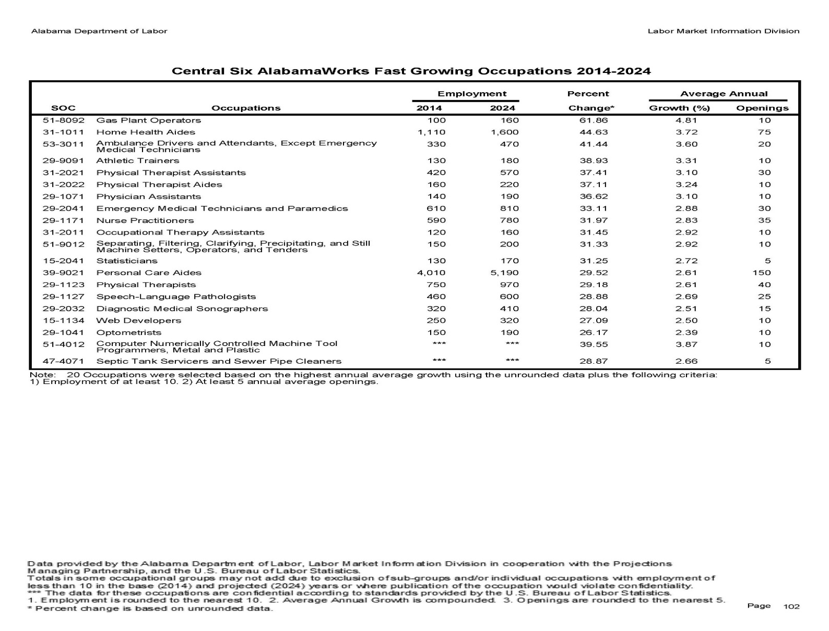The latest commuting data from 2014 shows that Region 4, as a whole experiences a net in commute of workers of 31,853. Region 4 retains 82.4% (357,892) of its workers who are living and working in the Region. This is significantly higher than most regions in Alabama. Healthcare employs 68,564 workers in the Region. In addition, 46.7 who live and work in the Region, averaged more than $3,333 per month. This is much higher than both in commuters and out commuters. The Region is retaining its younger workers, age 29 or younger, who both live and work in the Region equal to those who commute in. In the Region 17.6% of workers living in the Region work outside the Region; a majority of the out commuters travel to work in Tuscaloosa County (9,637), Montgomery County (7,542), most likely working within the state government and Madison County (7,165). The Region has experienced an overall loss of workers living and working in the region (15,548) since 2005, which could suggest that people are willing to commute farther to work than in the past.

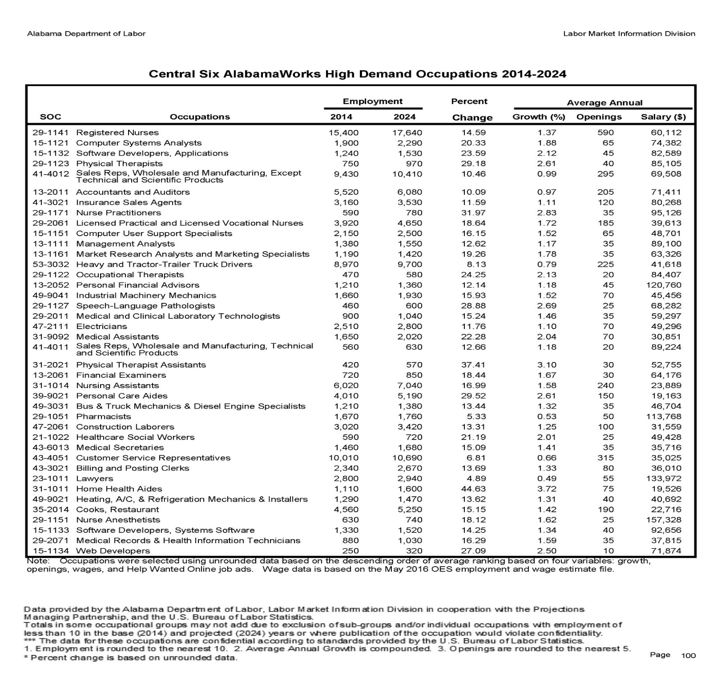

The CAPTE is engaged in a number of Workforce activities to include occupational skills training for Adults, Dislocated Workers, and Youth. The CAPTE provides On-the-Job Training opportunities to participants that are in need of this type of training. The CAPTE has established strong partnerships and programs to assist veterans, persons with disabilities and ex-felons. The CAPTE works with the Senior Community Service Employment Program (SCSEP) to assist those 55 and older with any additional services needed to find employment. The CAPTE’s assessment process assists participants with the development of a strong Individual Employment Plan.

Region 4 collaborates with the State of Alabama to provide Incumbent Worker Training to participants throughout the region. The CAPTE also collaborates with other workforce development, education, and training providers to ensure that the residents of the Region have access to many choices when it comes to developing occupational skills and obtaining employment. Additional workforce activities include training through the Adult, Dislocated Worker and Youth Programs business services activities to include Registered Apprenticeship program, and Work Based Learning.

Delivered through the partnership with the Alabama Career Center in the region are activities such as Trade Adjustment Act services, Vocational Rehabilitation services, Labor Market Information and several others. The CAPTE encompasses 4 comprehensive career centers, 1 satellite and 1 itinerate center.

The Region’s workforce activities include, but may not be limited to On-the-Job Training; Incumbent Worker training; training through Adult, Dislocated Worker and Youth Programs; Business Services activities; Registered Apprenticeship program; and Work Based Learning.

**Areas identified as weaknesses or needs improvement include:**

|  |
| --- |
| Youth training program setup |
| Need for greater Career Center presence in Blount and Chilton counties |
| Need for Title I staff person at Jefferson State Community College Satellite office |
| Need stronger collaboration between Career Centers and employers |
| Need greater utilization and partnerships with agencies that can help address drug and alcohol abuse issues |
| Encourage more employer and community college engagement |

**Areas identified as strengths are:**

|  |
| --- |
| Four (4) comprehensive career centers |
| Business service teams within the region |
| OJT and Work-based training programs |
| Active referral system between partners |
| Consolidated Region of CAPTE |
| AJL will be replaced with a new, more comprehensive and user- friendly system |
| Individual Training Account completion rates |
| High school training academy (Robotics) |

**V. Vision**

1. **What is the local board's strategic vision to support the area's economic growth and economic self-sufficiency? This vision should be supported by analysis of the local area (Section I) and align with Alabama's Combined State Plan (20 CFR 679.560(a)(5)).**

The strategic vision for CAPTE is as follows:

*To develop and implement programs that achieve and maintain an integrated, job-driven workforce system, which creates a diverse talented workforce for Central Alabama’s (Region 4) businesses thereby improving the quality of life for our citizens.*

1. **Identify the local area's goals for preparing an educated and skilled workforce (including youth and individuals with barriers to employment)(20 CFR 679.560(a)(5)).**

In addition to the negotiated performance goals with the State of Alabama, the CAPTE will have goals and objectives that will be developed through the strategic plan that are unique to its economy and workforce. Recognizing that young people between the ages of 16 and 24 are among the highest unemployed population in the Region, they will be a major focus of the CAPTE’s workforce development efforts.

By reaching out to more veterans and developing a plan for connecting with more Dislocated Workers through the Career Centers and community outreach activities, we will engage a larger pool of eligible participants.

To ensure that the residents of the Region are prepared for the challenges of an even more demanding work environment, the CAPTE will target the high demand occupations identified in the workforce analysis. The CAPTE will partner with additional agencies to deliver more soft skills training; provide access to more drug awareness programs through our partner agencies; and develop stronger support mechanisms. Additionally, the CAPTE will strategically align workforce efforts with agencies providing intensive services to participants with multiple barriers to employment.

**Area Goals**:

* Develop strategies to better assess potential employees before referring them for training and/or employment. Prescreen applicants for drugs before training and/or employment referrals.
* Expand the partnership with the Department of Human Resources (DHR).
* Strengthen business service relations with Employment Services to improve professional placement of participants.
* The state, and region, will do more to promote the Career Centers and their services.
* Replace AJL with a new system.

**VI. Local Area Strategy**

1. **Based on the analysis in Section IV, what is the local area's overall strategy to work with the entities that carry out the core programs and required partners to align resources available to the local area, to achieve the strategic vision and goals described in Section II (20 CFR 679.560(a)(6))?**

Comprehensive service providers throughout the CAPTE’s area will expand access to a seamless system of service delivery to eligible individuals through collaboration and partnerships with mandated partner agencies and programs. Such agencies include Wagner-Peyser, Senior Employment Community Program, TANF, Vocational Rehabilitation, Department of Education, Veterans Services and the State Unemployment Insurance program. The development of career pathways in key areas of healthcare, manufacturing, construction/energy, services/logistics, and retail/hospitality will ensure the successful participation in postsecondary and vocational education activities leading to an industry recognized certificate/certification.

The CAPTE’s workforce development strategies will not only take a sector based approach, but also a strengths-based, customer-centric approach that seeks to “meet job seekers” where they are in terms of work experience, skills and education. Through this model, we will broker relationships with employers that will focus on creating a variety of entry points for entrance, Mid, and Intermediate level job seekers, including: Work Experience, Transitional Jobs, Internships, Apprenticeships and On-the-Job Training programs. The CAPTE will focus on middle skilled occupations in high demand sectors, as well as on career pathways in areas such as retail and hospitality with entry-level opportunities for individual’s just entering employment or with limited employment history.

1. **What programs are included in the local area's workforce development system (20 CFR 679.560(b)(1)(i))? Provide a listing and brief description of each program.**

The programs that are included in the local area’s workforce development system are:

|  |  |
| --- | --- |
| Alabama Career Center System | Operated as a partnership between the Alabama Department of Commerce (WIOA Adult, Dislocated Worker, and Youth) and the Alabama Department of Labor (Wagner-Peyser, UI, TAA and Veterans). The Career Center System also collaborates with Adult Education, Rehabilitative Services, TANF, SNAP and Title IV of the Older Americans Act (SCESP). Statewide there are 26 Comprehensive Career Centers and 14 satellite and itinerant sites in the system. In PY2014 the Alabama Career Center System provided 352,837 individuals with Wagner-Peyser labor exchange services and 7,924 individuals with WIOA training services, serving low-income Adults, Youth, and Dislocated Workers. |
| Adult Education | Adult Education services are offered through the Alabama Community College System (ACCS) throughout the state. Adult Education has been an active partner with the Alabama Career Center system since 2001 and will continue to expand services within the Career Centers under  WIOA. |
| Alabama Department of Labor – Wagner-Peyser, Unemployment Insurance, Trade Act, and Veterans Services | The Alabama Department of Labor (ADOL) houses the Wagner-Peyser program (Employment Service), Unemployment Insurance, Trade Act, and Veterans Services programs. ADOL Wagner-Peyser and WIOA Title I programs have been collocated as part of the Alabama Career Centers since 2001. The Alabama Job Link (AJL) is provided by the ADOL. Alabama Job Link is the online job seeker and employer registration system that provide job seeker skills, abilities and work history with employers posting job openings in the system. ADOL provides Trade Act services and Veterans employment representatives in the Career Centers. |
| Alabama Department of Rehabilitation Services (ADRS) | The Department of Rehabilitation Services Vocational Rehabilitation Services (VRS) provides specialized employment and education related services and training to assist teens and adults with disabilities to become employable. Services include skill assessments, counseling, training programs, job placement, assistive technology and transportation. Since 2001 the VRS has been an active partner in the Alabama Career Center System |
| Alabama Department of Human Resources (TANF and SNAP) | The Alabama TANF Program operated by the Alabama Department of Human Resources. TANF provide family assistance to provide income to low income one-parent families needing support to provide basic needs for dependents. The JOBS program is the welfare to work component of family assistance. The JOBS Unit provides assessment services to all program clients for an evaluation of their skills, prior work experience and employability. Individuals on family assistance determined to be ready to engage in work activities will be placed in a work-related activity such as subsidized/unsubsidized employment, job search, job readiness classes, skills training or GED classes.  The Supplemental Nutrition Assistance Program (SNAP) also operates a work-based program with the Alabama Department of Labor. |
| Alabama Department of Senior Services – Senior Community Service Employment Program (SCSEP) | The Senior Community Service Employment program provides work-based job training for older Americans age 55 and up. |
| Central Six Development Council | Central Six (6) Development Council develops programs to accommodate current and future training needs. |
| Alabama Industrial Technology Network | Provides training to industry and business. |

1. **How will the local board support the strategies identified in Alabama's Combined State Plan and work with the entities carrying out core programs and other workforce development programs, including programs of study authorized under the Carl D. Perkins Career and Technical Education Act of 2006 ( 20 U.S.C. 2301 *et seq.)* to support service alignment ( 20 CFR 679.560(b)(1)(ii))? Provide information concerning how the local board will work with entities carrying out core programs to:**
2. **Expand access to employment, training, education, and supportive services for eligible individuals, particularly those with barriers to employment ( 20 CFR 679.560(b)(2)(i));**

Through an expanded collaborative partnership, the region will be able to provide access to a full array of employment training education and supportive services for eligible individuals and particularly those with barriers to employment. The CAPTE will carry out its programs consistent with the State’s Combined Plan and will align its activities to make its programs and services available to participants of the Carl D. Perkins Career and Technical Education Act and all other mandated partners.

1. **Facilitate the development of career pathways and co-enrollment, as appropriate, in core programs (20 CFR 679.560(b)(2)(ii)); and**

Co-enrollment of Trade Adjustment Act and Title I participants has been a part of the majority of the Regional service process. The board will explore previous successes with GED/Adult Education students enrolling in high demand occupational training simultaneously. It is an area that the CAPTE will review and assess to determine expansion of this activity. Given the demands of the local job market, the Board will look at all options to prepare the local workforce for success in the labor market.

1. **Improve access to activities leading to a recognized post-secondary credential (including a credential that is an industry-recognized certificate or certification, portable, and stackable) (20 CFR 679.560(b)(2)(iii)).**

The CAPTE has made strides in providing access to recognized post-secondary credentials and making them widely available to all eligible participants. Focusing on career pathways and training in high demand occupations will continue to be a major focus of the regional workforce efforts.

Making online/distance training and learning more widely available through the various service providers, along with improved access to transportation will also improve overall access to training for participants.

d. **What strategies and services will the local area use to:**

1. **Facilitate engagement of employers in workforce development programs, including small employers and employers in in-demand industry sectors and occupations ( 20 CFR 679.560(b)(3)(i));**

The CAPTE Board will use various approaches to facilitate the engagement of employers. The board supports workforce efforts by participating in professional associations and sharing information on workforce development. In addition, staff participates in numerous career and job fairs throughout the year. Job fairs are sponsored or initiated by the Alabama Career Center, while others are supported by partners or employers. The Alabama Career Center also has business service representatives and job developers that meet with employers regularly to provide information, exchange ideas, and ensure that we are providing the services needed to meet their needs.

1. **Support a local workforce development system that meets the needs of businesses in the local area (20 CFR 679.560(b)(3)(ii))**

Not only does the Alabama Career Center support workforce development in the local area, but the Alabama Career Centers are at the heart of the workforce development activity serving business in Region 4. Key among the strategies to meet the needs of local business is to maintain current and accurate information on their employment needs. Face-to-face contact as well as constantly updating Labor Market Information (LMI) data provides the information needed to assist businesses. Making sure that the labor force has the necessary tools to fill the employment needs of those businesses is a major part of the strategy. While some business needs are less sophisticated than others, they all have needs that must be met. The CAPTE Board provides that training through its education and training partners. It is important to take the next step, which is to match those employees with the employers and make sure the employee has the tools needed to obtain and sustain employment.

1. **Better coordinate workforce development programs and economic development (20 CFR 679.560(b)(3)(iii))**

The CAPTE Area is centered in the most populous region in the State of Alabama. In addition to maintaining a close working relationship with economic development leaders in the local area, we have representatives of economic development on the local board. The local area receives leads on development and employee needs from local economic development staff when appropriate. This assists greatly in reaching businesses early to assess their needs and provide necessary services.

This close working relationship also assists the CAPTE with preparing for any shifts in employment needs that may not align with what has been reported through LMI data.

1. **Strengthen linkages between the one-stop delivery system and unemployment insurance programs (20 CFR 679.560(b)(3)(iv))**

The CAPTE will continue to work with the Alabama Department of Labor to gain direct access to Unemployment Insurance (UI) data. The UI data is invaluable in assessing the previous status of individual participants, but is currently only accessible through Wagner Peyser staff.

1. **Implement initiatives such as Incumbent Worker training programs; on-the-job training programs; customized training programs; industry and sector strategies; career pathways initiatives; utilization of effective business intermediaries; and other business services and strategies designed to meet the needs of local area employers. Any of the above initiatives the local area chooses to implement should be in support of the other strategies to serve employers outlined above in Section III.d. (20 CFR 679.560(b)(3)(v)).**

The CAPTE currently provides Incumbent Worker training in conjunction with the State of Alabama. With the implementation of WIOA, the Board may become more involved in directly providing Incumbent Worker training. This will be determined by the needs of local businesses.

On-the-Job Training is available under the WIOA Act. It is a service that is available to businesses if they choose to take advantage of it.

Within the Region there is a state-sponsored Regional Workforce initiative called the Central Six (6) Regional Development Council. One of the services provided by Central Six (6) is the development of industry clusters and sector strategies. The CAPTE has been working with Central Six (6) and meeting with employers to discuss sector strategies and industry needs. The CAPTE will utilize the information provided by Central Six (6) to develop strategies to meet the needs of the businesses and ensure that training is aligned with the needs of those businesses.

The CAPTE has not formed any formal career pathways initiatives. However, it is highly likely that once the new WIOA board meets, a strategy will be developed that is consistent with the needs of local businesses and the clients we serve.

**e. How will the local board coordinate local workforce investment activities with regional economic development activities carried out in the local area (20 CFR 679.560(b)(4))?**

Region 4 has an extensive network of local business, supportive services and education and training interests. Those interests not only serve Region 4, but the other outlying counties impacted by regional activities. In addition to being closely aligned with existing regional workforce and economic development organizations, the CAPTE will work with local economic development partners. Maintaining a strong economic development presence on the local board will also provide additional input into workforce development strategies. Workforce development managers meet often with economic development officials and government leaders to keep abreast of economic and workforce development needs.

The creation of the CAPTE provides even greater interaction regionally, with other local economic development officials and government leaders than allowed under a one-county local area.

**f. How will the local board promote entrepreneurial skills training and microenterprise services (20 CFR 679.560(b)(4))?**

The CAPTE plans to coordinate entrepreneurial skills training with small business development programs in region. Region 4 has one (1) of the strongest centers of microenterprise in the country in its award-wining Innovation Depot. The Innovation Depot is a state of the art business incubator that has birthed hundreds of businesses in the Birmingham area. There are other small business development centers in the area such as the Bessemer Business Center and the Birmingham Business Resource Center that provide services to entrepreneursand that have had great successes. The strategic location and type of business will determine which of these services is most beneficial to the business.

Within the local area, several organizations offer small business financial and technical assistance. All potential entrepreneurs should take advantage of these services, which are free in many cases. The CAPTE encourages and supports the entrepreneurial spirit whenever appropriate among its current and former program participants.

**g. Provide a description of the one-stop delivery system in the local area, including:**

1. **How the local board will ensure the continuous improvement of eligible providers of services through the system and that such providers will meet the employment needs of local employers, workers, and jobseekers (20 CFR 679.560(b)(5)(i))**

The Alabama Department of Commerce receives applications and selects Eligible Training Providers. It reviews the performance information on each provider~~s~~ to ensure that they have been performing beyond the minimally acceptable level. Region 4 will work with the state to ensure that Eligible Training Providers are performing at a level consistent with established standards.

1. **How the local board will facilitate access to services provided through the one-stop delivery system, including in remote areas, through the use of technology and other means ( 20 CFR 679.560(b)(5)(ii))**

Region 4 is an urban, densely populated area. Many of the clients served reside in local cities with digital access. Very few of the clients served in the Alabama Career Centers are not able to access services directly. The Alabama Career Centers have historically provided remote access through a number of venues. The new Service Centers will continue to provide remote access to services through the widely utilized Alabama Job Link system, internet, email, social media, and other related online applications.

1. **How entities within the one-stop delivery system, including career center operators and the career center partners, will comply with WIOA sec. 188, if applicable, and applicable provisions of the Americans with Disabilities Act of 1990 (42 U.S.C. 12101 *et seq.)* regarding the physical and programmatic accessibility of facilities, programs and services, technology, and materials for individuals with disabilities, including providing staff training and support for addressing the needs of individuals with disabilities ( 20 CFR 679.560(b)(5)(iii))**

The Alabama Career Center Operator and partners will comply with the provisions of Section 188, regarding Nondiscrimination. Each entity engaged in providing services to participants and/or maintaining a physical location in the Alabama Career Center will be subject to the provisions of WIOA section 188 and the Americans with Disabilities Act of 1990. The compliance with these policies will be a part of any agreement entered into with any partner. The Alabama Career Center will provide the same unfettered access to all services for those individuals with disabilities.

1. **What are the roles and resource contributions of each career center partner (20 CFR 679.560(b)(5)(iv))?**

The roles of each Alabama Career Center partner and its contribution to the operation of the center will be established through a Memorandum of Understanding, One Stop Service Agreement and/or a Resource Sharing agreement. Each partner is expected to provide ongoing participation in the Alabama Career Center~~s~~. Each partner will share in the infrastructure cost and the cost of service delivery as required by the Act. The specific role of each partner and the details of cost sharing will be provided in the Memorandum of Understanding and other appropriate agreements.

1. **Provide a description and assessment of the type and availability of adult and dislocated worker employment and training activities in the local area (20 CFR 679.560(b)(6)).**

Adults and Dislocated Workers have access to the following career service activities within the local area:

• Initial assessment of skill levels, aptitudes, abilities and supportive services needs.

• Alabama Joblink usage including enrollment at <https://joblink.alabama.gov/ada/r/>.

• Internet browsing for a job, career information, and training searches.

• Training information.

• Labor market information, including industry cluster information.

• Information on the CAPTE WIOA partner services and supportive services.

• Assistance in establishing eligibility for appropriate programs.

• Career counseling.

Before providing training services, a staff member must determine that an individual is unable to obtain employment through basic career services among other criteria to ensure limited training funds are spent on customers most in need. The WIOA staff initially meets with a participant; assess his or her skills; consider labor market conditions; and determine that basic career services will not be sufficient to result in employment for the participant. The provision of training or other needed services can then be provided sequentially, concurrently, or in the order that makes the most sense for the individual.

Participation in the Adult or Dislocated Worker program requires the participant be committed to specific steps toward obtaining full-time employment. Career Planners write an Individual Employment Plan (IEP) with each participant that analyzes and identifies the full-time employment objectives. The IEP specifies the occupational goals of the participant, based on assessment, testing, and conversations with the participant. The participant is guided through a series of activities and interactions customized to their goal, which may be employment, training or other assessments such as MyNextMove. The IEP drives the services that each customer will access to succeed in gaining employment and is a living document that adjusts to customers’ changing needs.

The CAPTE provides a variety of training and employment activities that exist within the local area. Funding may not be available to directly support participation in all training activities, but Region 4 WIOA staff provides guidance on career planning that may involve one (1) or more training activities and available funding resources.

1. **Provide a description of how the local board will coordinate workforce investment activities carried out in the local area with statewide rapid response activities (20 CFR 679.560(b)(7)).**

Each One Stop Center has a partner relationship with the Rapid Response Team. The Department of Commerce is responsible for all Rapid Response activity statewide. Each Center joins that Rapid Response Team whenever a local company is at issue.

Initial contact with the employer is made by the state’s Rapid Response Coordinator. Any layoff aversions activity is conducted by the state. The state then notifies the CAPTE Board. The CAPTE Board staff then participates in Rapid Response activities until the process is concluded. Through this partnership, a variety of services may be offered and utilized by the affected workers.

**j. Provide a description and assessment of the type and availability of youth workforce investment activities in the local area including activities for youth who are individuals with disabilities, which must include an identification of successful models of such activities (20 CFR 679.560(b)(8)).**

The CAPTE and its partners provide local youth with an academic skills assessment and an interest inventory to determine a career pathway. For youth with disabilities, the assessment and career pathway will be completed jointly with the Department of Vocational Rehabilitation. Once a career pathway has been determined, the youth will have access to GED tutoring; high school diploma recovery; construction job training; stem focused training; and medical assistant skills training. During career exploration, each youth will be provided with assistance that aligns with the 14 elements listed in the Act. After the youth has received a nationally recognized certificate from their chosen program, they will receive additional assistance enrolling in advanced education or gaining employment. Once the youth becomes actively enrolled in education or has gained employment, staff will continue to show support, encouragement and further assistance to help them to complete their educational goals or remain employed.

Youth with disabilities are afforded the same opportunities as individuals without disabilities. For youth with a major disability as a barrier, the CAPTE work~~s~~ with partners to provide additional services uniquely suited to assist them and ensure their success.

The CAPTE will strategically provide both In-School and Out-Of-School youth program when appropriate.

**k. How will the local board coordinate relevant secondary and post-secondary education programs and activities with education and workforce investment activities to coordinate strategies, enhance services, and avoid duplication of services ( 20 CFR 679.560(b)(9))?**

Developing and maintaining strong working relationships and open lines of communication and coordination with education and training providers are essential to the development of a strong workforce system. The CAPTE staff meets frequently with postsecondary education partners in different settings and to address a variety of concerns and opportunities. Presidents of the local community colleges are represented on the CAPTE Board and are an important part of the strategic planning effort. As part of our continuous improvement strategy, open lines of communication are maintained with secondary education programs to ensure program alignment.

The CAPTE Board has also established the Central Alabama Workforce Collaborative Network. This network of partner agencies is designed to share information about each program and to limit duplication of services. The collaborative is comprised of approximately 30 required and volunteer partners. This initiative has helped to build new partnerships and stronger alliances among all of the partners.

**l. How will the local board coordinate WIOA Title I workforce investment activities (adult, dislocated worker, and youth programs) with the provision of transportation and other appropriate services in the local area (20 CFR 679.560(b)(10))?**

Chief among the barriers to training and employment for the vast number of participants is the availability transportation and affordable childcare. The CAPTE Board will utilize the resources available in the local area to meet these needs.

**m. Provide plans and strategies for maximizing coordination, improving service delivery, and avoiding duplication of Wagner-Peyser Act services and other services provided through the one-stop delivery system ( 20 CFR 679.560(b)(11)).**

A major step in this direction will be the co-locating of WIOA core activities and core partners in the Alabama Career Center facility. Locating Wagner Peyser, WIOA and other partner agencies in one (1) facility will tremendously improve coordination and delivery of services, thereby preventing duplication of services.

**n. How will the local board coordinate WIOA Title I workforce investment activities (adult, dislocated worker and youth programs) with adult education and literacy activities under WIOA Title II? This description must include how the local board will carry out the review of local applications submitted under Title II consistent with WIOA Secs. 107(d)(11)(A) and (B)(i) and WIOA Sec. 232, for example, promoting concurrent enrollment in programs and activities, as appropriate (20 CFR 679.560(b)(12)).**

Adult Education services are currently provided in the Alabama Career Center~~s~~. It is also provided at several satellite locations through partnerships with community colleges and adult education providers within the local service area. Adult education providers must have a good performance record and be accessible to the public without cost. The CAPTE will participate in the co-enrollment of participants in adult education and occupational skills training where appropriate.

**o. Attach current copies of Memorandums of Understanding or other executed cooperative agreements which define how all local service providers, including additional providers, will carry out the requirements for integration of and access to the entire set of services available in the local one-stop delivery system (20 CFR 679.560(b)(13)).**

The MOU Narrative has been executed by all of the Partners and submitted to the Commerce Workforce Development Division.

**p. Provide a statement indicating that the local area will negotiate local levels of performance consistent with WIOA sec. 166(c) with the Workforce Development Division (WDD) and that these performance levels will be included in each year's Grant Agreement. These levels will be negotiated when the U.S. Department of Labor and other applicable federal agencies finalize performance levels for the state (20 CFR 679.560(b)(16)).**

The CAPTE will negotiate local levels of performance consistent with WIOA sec.166(c) with the Workforce Development Division and these performance levels will be included in each year’s grant agreement.

**q. What actions will the local board take toward becoming or remaining a high-performing board, consistent with the factors developed by the state board (20 CFR 679.560(b)(17))?**

In addition to the factors outlined in the state plan, the CAPTE will work with the state to complete the co-location of all of its Birmingham office within the region.

The CAPTE Board will evaluate all of the approved training programs to ensure that they are suited to help the local area achieve and maintain a high level of performance. In addition, a review of all policies and procedures by staff and the CAPTE Board will be implemented. Policies and procedures that are obsolete or ineffective will be eliminated.

The Alabama Department of Commerce, Workforce Development Division is in the process of procuring a client tracking system that will allow the CAPTE Board to assess real time performance for program year 2018.

**r. How will individual training accounts be used to provide training services to adults and dislocated workers? Will contracts for training services be used? If training contracts for services are used, how will this be coordinated with the use of individuals training accounts? How will the local board ensure informed customer choice in the selection of training programs regardless of how the training services are to be provided (20 CFR 679.560(b)(18))?**

Training services provided by Region 4 are directly linked to in-demand industry sectors and occupations. All Adult and Dislocated Workers will receive an assessment that will identify the possession of any barriers. If training is identified as a barrier, the participant may receive an Individual Training Account or ITA.

The CAPTE provides diversified job-driven training opportunities for individuals, including occupational skills training, work based training, and registered apprenticeships. All funded training programs must lead to a recognized post-secondary credential and/or industry-recognized credential aligned with in-demand industry sectors or occupations.

The CAPTE has innovative programs and strategies designed to meet the needs of employers, which may include employed worker training programs such as customized training, career pathways, and On-the-Job Training.

Region 4 has placed a priority on effective work-based strategies that meet employers’ workforce needs, including On-the-Job Training, Incumbent Worker Training and Registered Apprenticeships. It is anticipated that the board will implement procedures to concentrate Dislocated Worker and Adult WIOA ITA dollars to occupations within the following industry sectors:

1. Healthcare
2. Manufacturing
3. Information Technology
4. Financial & Professional Services

Career pathways, customized training, On-the-Job Training, Apprenticeship and Internships will still apply to all targeted occupations within any industry sector.

Region 4 case management staff determines the customer’s need for WIOA funded training services following completion of an interview, evaluation, or assessment, and career planning based on the following criteria:

1. Candidate is unable or unlikely to obtain or retain employment that leads to economic self-sufficiency or wages comparable to or higher than wages from previous employment, through career services.
2. Candidate is in need of training services to obtain or retain employment that leads to economic self-sufficiency or wages comparable to or higher than wages from previous employment.
3. Candidate has selected a training program or training services that are directly linked to the demand occupations listed on the state’s ETPL that will lead to employment opportunities in the local area or the planning region.
4. Candidate has the skills and qualifications to successfully participate in the selected training program.
5. Candidate does not currently possess skills in a demand occupation.
6. Candidate has limited skills in the chosen training program that will significantly reduce employment opportunities.
7. Candidate has been unable to secure self-sufficient employment with current skills. Customer is in need of assistance with training in a targeted occupation in order to become more skilled with the goal to retain employment following the subsidized OJT training period.

**s. Describe the One-Stop delivery system's current intake and case management information system(s). Are all WIOA and career center partners using the same system? No. How do WIOA and career center partners plan to implement and transition to an integrated, technology-enabled intake and case management information system (20 CFR 679.560(b)(20))?**

The Region 4 Career One-Stop delivery system advocates and supports an integrated information system at the state and local level that would allow entities that carry out core programs to better coordinate service delivery for mutual customers and cross program referrals. The Alabama Career Center will maximize the utilization of technology to consolidate, streamline services and enhance the overall customer experience.

Systems are not fully integrated at this time, plans are underway to do so during the upcoming program year.

Region 4 Career One-Stops utilize the Alabama Joblink database system (AJL), which supports programs and manages all of our Career Center traffic and participant records. Customers entering the Career Centers sign in through the AJL system located in the lobby. Veterans and program participants are identified by this system and programmatic staff receives automated notifications. Customers are able to choose what category of assistance, including partner programs they need to access upon entering the building. Career Center traffic reports are shared with all of our One-Stop Career Center staff, members, and core partner programs.

**t. What policies does the local board have in place for the local one-stop delivery system that ensure priority for adult career and training services will be given to recipients of public assistance, other low-income individuals, and individuals who are basic skills deficient (20 CFR 679.560(b)(21))?**

The CAPTE board with accompanying modifications as needed, will implement many of the former policies of the WIA board. The local board will review all previous policies and update them to comply with the new vision and strategies of the board in compliance with WIOA.

Since both WIA and now WIOA, made recipients of public assistance; other low-income individuals; and individuals with basic skill deficiencies a priority, the CAPTE board will seek to ensure that those individuals are given priority just as they did under WIA.

**u. How will the local area, and in particular the career centers, comply with the Jobs for Veterans Act requirements?**

The Alabama Career Center will continue to provide priority services to veterans and eligible spouses (including widows and widowers). The board will establish new policies pertaining to priority of services for Veterans and eligible spouses that the local area staff follows. In addition, these policies will be revisited with the purpose of enhancing or making improvements as necessary.

**VII. Service Provider Selection Policies**

1. **Provide a description of the competitive process that will be used to award any subgrants and contracts for WIOA Title I activities (20 CFR 679.560(b)(15)).**

The CAPTE issues a Requests for Proposal~~s~~ (RFP) when soliciting proposals for services. The advertisement of the RFP is approximately 30 days. Once the proposals arrive, they are time and date stamped. The proposals are reviewed by staff for timeliness, completeness, adherence to the published proposal guidelines and to determine if the presence of the minimum information needed to rate the proposal. The reviewing committee then reviews the proposals.

After an oral presentation and rating of the written proposals, the reviewing committee scores them all. Based on the scores, the reviewing committee makes recommendations for funding to the CAPTE Board.

For those services that do not require competitive bidding such as the Adult and Dislocated Worker eligible training providers, the CAPTE follows the rules established by the Alabama Department of Commerce, Workforce Development Division.

1. **Identify local board criteria for awarding grants for youth activities.**

The local board criteria include:

Proposal Guidelines and Submission Instructions; Due Date; Submittal Requirements; Format Requirements; Cover Page; Table of Contents; Problem Statement; Plan and Implementation; WIOA Mandated Performance Outcomes; Program Performance Measures & Outcomes; Statement of Experience; Financial Statements/Audit Requirements; Insurance Requirements; The Proposal Budget; The Budget Narrative; Organizational Chart; a copy of all formalized agreements pertaining to the proposal; Formalized Agreements; outline of all program costs; Program and participant Costs; and a listing of In-kind or leveraged funds;

Each proposal is evaluated on the following:

* Proposal Narrative
* Budget Narrative
* Oral Presentation

1. **How will the local area determine service provider suitability for inclusion on the Eligible Training Providers List?**

For Eligible Training Providers of Adult and Dislocated Worker training, initial eligibility will be determined by the Alabama Department of Commerce-Workforce Development Division.

1. **How will the local area secure the required performance information from service providers?**

The Alabama Department of Commerce-Workforce Development Division provides to the CAPTE performance data for the Eligible Training Providers of Adult and Dislocated Worker training.

**VIII. Monitoring & Oversight Policy**

1. **Provide a copy of the local area's monitoring and oversight policies and procedures. (See below)**

**CENTRAL ALABAMA PARTNERSHIP FOR TRAINING AND EMPLOYMENT (CAPTE)**

**MONITORING POLICIES AND PROCEDURES**

The CAPTE has established an oversight and monitoring process, which includes both fiscal and programmatic compliance reviews of all WIOA contracts through desk reviews and random sampling of the Eligible Training Providers. These activities are required to fulfill the Region’s mandated oversight responsibilities as a Workforce Innovation Opportunity Act (WIOA) local area in accordance with Section 107 (d)(8) of Workforce Innovation Opportunity Act.

The monitoring process provides feedback to management through observations, findings, and recommendations. It provides for knowledge of what is happening at WIOA funded programs and can provide "warning signals" that issues may be developing so that improvement measures or corrective actions can be taken immediately.

The CAPTE monitor will identify and analyze problems found through compliance review and performance review. Reviews will identify technical assistance needs revealed during on-site monitoring visits. Recommendations for corrective action in monitoring reports and follow-up on the recommendations to ensure that corrective action occurs are the result of these activities.

**Program** **Monitoring**

Program monitoring ensures that contracted services are carried out. It also addresses ‘eligibility' of participants, counseling, orientation, preparation for training and placement, and delivery of all services specified in the contract.

**Performance Monitoring**

Performance monitoring ensures the contractor is providing said services and said services are provided in conformance with standards specified in the contract and WIOA regulations incorporated in the contract.

**Compliance Monitoring**

Compliance monitoring ensures the contractor is carrying out the stated terms and conditions of the contract that are administrative.

**Fiscal Monitoring**

Fiscal monitoring ensures the contractor has financial systems in place required by contract terms. It also ensures the contractor’ financial performance is commensurate with program performance.

**SCOPE**

The CAPTE monitor shall be responsible for conducting the monitoring of contractors. The monitor shall review participant files to determine eligibility. Files shall contain evidence of pertinent client activity records; program activities; and services to participants including review of classroom training. OJT, work experience, supportive services information will be included as well. If necessary, the monitor will interview participants, staff, instructors and employers. The monitor will review actual-versus-planned activities to assess progress toward goals and objectives. The review will include the identification of problems (existing or emerging) and initiate corrective actions as appropriate. Performance outcomes reviewed may include: Employment Rate; Median Earnings; Credential Rate; Measurable Skills Gain. As it relates to Youth, Performance outcomes will consist of Placement in Employment, Education or Training; Median Earnings; Credential Rate; and Measurable Skills Gain; Customer Satisfaction and/or any Employer measures may also be reviewed. Reviews of administrative and management policies and procedures will be conducted to determine compliance with EEO and nondiscrimination reporting requirements and if grievance procedures exist and complaints are resolved in accordance with established procedures.

The appropriate Jefferson County fiscal staff or contracted agency will review compliance with established accounting and internal controls, fiscal and procurement policies and procedures, and examine claims for reimbursements verified against financial records and other supporting documentation

**FREQUENCY**

Compliance monitoring will be conducted at a minimum of once each Program Year. Performance monitoring will be conducted a minimum of once each program year through desk review and on-site visits. The quality' of this data analyses depends on the capabilities of the contractor's management information system to generate timely and accurate reports. All monitoring will be done in accordance with the County’s Fiscal Manual.

**TECHNICAL ASSISTANCE**

Technical Assistance is formal or informal training provided to contractors independently as a result of an identified need revealed through a monitoring review.

**Problem Solving/ Correction**

A major element of monitoring is problem correction and/or problem solving. Technical assistance may be offered to strengthen Contractor's performance as well as prevent weaknesses from becoming problem areas that require correction. This may be as simple as identifying a lack of procedure or an actual procedure which, if continued, will produce deficiencies.

**MONITORING REPORT**

Each on-site monitoring visit will be documented by a written report. Monitoring reports are official records of the CAPTE staff reviews of contractor's program at a certain point identified in the period of performance. It constitutes the basis for future assessment. Monitor's findings are available for federal, state and public inspection. Monitoring reports will be prepared on all on-site visits and when combined with the desk review report, will provide the background of the program; follow-up on previous findings, current findings; (positive or negative); and recommendations (if any) for corrective action with timeline for implementation. Any regular or special review and any technical assistance provided to the contractor are also included in the report.

The monitoring report is issued as promptly as possible to make the information available for timely consideration and action by the management of both the CAPTE and program operators. If there are significant findings, a copy shall be distributed to the contractor identifying definitive corrective actions that may be taken.

**Release of Monitoring Report**

The original copy of the completed monitoring report shall be filed in the contract folder and shall be available for review by federal and state officials.

**Retention of Monitoring Report**

The original copy of the completed monitoring report and other records related to the monitoring activities must be retained for three (3) years from the date of submission of the final expenditure reports regarding the funding sources being monitored. Should any litigation, claim, audit or other action involving the records starts before the expiration of the three (3) year period, the records must be retained until completion and resolution of all such actions or until the end of the three (3) year period, whichever is later.

**CORRECTIVE ACTION**

Through desk and on-site reviews, the CAPTE monitor makes recommendations in the monitoring report for corrective action on identified problem areas.

**Problem Identification/ Analysis**

Problem areas and other deficient conditions will be analyzed and discussed so that difficulties encountered by contractors can be presented with a balanced perspective in the monitoring report. Difficulties/problems are essentially deviations from a usual or desired condition. The CAPTE monitor will explain to the contractor what constitutes an acceptable condition.

**Corrective Action Plan**

The type and extent of the problem encountered may require action at more than one level.

**Technical Assistance or Additional Information:**

Will be provided when deficient condition is caused by inadequate information or training.

**Corrective Action Plan:**

The contractor must implement the recommended corrective action in accordance with the adopted plan and within the timeframe indicated by the monitor in his /her monitoring report. The implementation will be closely followed-up by the monitor (1) to determine the overall efficiency and effectiveness of the approach and (2) to measure progress toward resolving the problem. The contractor is required to respond in writing to the monitor's recommendations to acknowledge that the corrective action plan is being implemented.

**Directive:**

If the problem has resulted from an incorrect practice, discontinuation of the practice and substituting a correct procedure will alleviate or resolve the problem.

**Policy Change:**

Some procedures may not be workable in a particular circumstance. The monitor will submit appropriate recommendation for procedure change to allow performance to be acceptable.

As the final step in the monitoring process, the monitor will follow-up on corrective action recommendations as well as on the results of any technical assistance. The monitor may also extend the target date for completion of the corrective action if the contractor's request for extension is reasonable and has provided justification for such action.

**Follow-Up Methodology**

If a corrective action is crucial to the operation of the program or is required immediately to resolve a problem involving questioned costs, a follow-up visit for ensuring that the correction action has been implemented may be necessary. In other situations corrective actions may be followed-up during the course of the next regular monitoring visit (this may be specified in the monitor’s report or follow-up letter).

Corrective actions may be verified through a desk review. The contractor in response to a monitoring report may submit data documentation.

Follow-up to verify eligibility and services, in addition to a review of participant records conducted by the monitor in the course of the on-site monitoring visit, the CAPTE staff will review data entry information for affected participants in the state’s data entry system.

In the case of incomplete participant files reviewed during site visits, the monitor may allow the submission of photocopies of missing data for purposes of data validation. The contractor's cooperation will be required to obtain the evidence.

In the event of any inconsistencies, Contractor’s will be contacted regarding such inconsistencies and will be informed of the appropriate corrective action (including a specific period to address the situation or implement the correction action).

**IX. Grievance Procedures and Policies**

Provide a copy of the local area's Grievance Procedures and Policies (See below).

The Workforce Innovation Opportunity Act (WIOA) is a federal law designed to strengthen the United States workforce development system through innovation and alignment, employment, training, and education programs in the United States and to promote individual and national economic growth, and for other purposes

The CAPTE workforce development area receives funds to provide WIOA programs, services and activities from the U.S. Department of Labor via the Alabama Department of Commerce-Workforce Development Division.

**WHO MAY USE THE GRIEVANCE AND COMPLAINT PROCEDURES**

These grievance and complaint procedures apply to WIOA programs, services, and activities in the CAPTE workforce development area. The procedures may be used by any person who believes any rules or agreements under the WIOA have been violated in any CAPTE WIOA program activity.

**TIME CONSTRAINTS OR LIMITATIONS TO FILE A GRIEVANCE OR COMPLAINT**

Discrimination complaints must be filed within 180 days (within six months) of the date you believe the discrimination occurred.

Other WIOA complaints and grievances are those that arise from program activities or agreements. An individual must file a grievance or complaint within one year of the date the violation occurred.

**HOW DO I FILE A GRIEVANCE OR COMPLAINT?**

A grievance or complaint about a CAPTE workforce development area program or activity, but not one claiming discrimination is first discussed with a supervisor; or a counselor at a training location; an employer human resources or personnel manager; or a person responsible for helping individuals with complaints in the Career Center where services were received. If the complaint is not satisfactorily settled within ten (10) days, a written complaint may be forwarded within five (5) days after the 10 day expiration to the Jefferson County Director of Human-Community Services and Economic Development, located at, Jefferson County Courthouse, Room A-430, 716 Richard Arrington Jr. Boulevard North, Birmingham, Alabama 35203. Include claimants name, address, telephone number, and the name and address of the staff individual/s believed to have responded inappropriately.

The local area may conduct an investigation hold a hearing, or take other action to settle the complaint. If a decision about a complaint is not received within 60 days, or the decision is unsatisfactory, an appeal may be filed in writing to: Division Director, Department of Commerce, Workforce Development Division, 401 Adams Avenue, P.O. 5690 Montgomery, Alabama 36103-5690. You should file the appeal within 10 days after receipt of the initial decision.

If the complaint is about labor standards violations (e.g. an employer disobeyed a law or rule about working conditions, wages and benefits, health and safety standards) covered by a collective bargaining agreement (i.e., an agreement between and employer and a union about wages, hours of labor and working conditions), the grievance may be filed through a binding arbitration. Contact the supervisor, personnel manager or union representative for information about the application and the steps that should be followed.

**THE CAPTE WORKFORCE DEVELOPMENT AREA IS AN EQUAL OPPORTUNITY EMPLOYER.**

**EQUAL OPPORTUNITY IS THE LAW**

It is against the law for the CAPTE workforce development area or any person, agency, organization, employer or training provider that receives WIOA funds to discriminate against any person in the United States on the basis of race, color, religion, sex, national origin, age, disability, political relationship or belief, and against any person who benefits from a WIOA program because of the person’s citizenship, being a legal immigrant, or being a WIOA participant.

The CAPTE workforce development area agencies, organizations, employees, and training providers that receive WIOA funds will not discriminate in any of the following ways:

1. Displaying preferential treatment towards individuals regarding admission to a WIOA program or activity.
2. Providing opportunities or treatment to an individual in a WIOA program or activity that is adverse or preferential.
3. In making employment (job) decisions related to a WIOA program or activity.

Discrimination based on race, color, religion, sex, national origin, age, disability, political relationships, beliefs or if a WIOA participant and think someone discriminated because of your citizenship, being a legal immigrant, or being a WIOA program participant, a complaint may be filed within 180 days of the date the discrimination occurred with either the Equal Opportunity Officer, Department of Commerce, Workforce Development Division, 401 Adams Avenue, P.O. 5690, Montgomery, Alabama 36103-5690 or the Civil Rights Center, U.S. Department of Labor. This office will explain the avenues of relief available to resolve the complaint.

Grievance and complaint procedures were explained to me by:

Employee’s Name ____________________________ Title _________________________

Agency ______________________________________ Date ________________

Applicant’s/Registrant’s/Participant’s Signature__***________________________________***

**X. Comment Period**

What process will the local board use to provide a public comment period no longer than thirty days prior to submission of the plan? How will the local board ensure that the public, particularly representatives of businesses, education, and labor organizations, have an opportunity to have input into the development of the plan (20 CFR 679.550(b), 679.560(b)(19))?

The CAPTE local area plan will be posted on the Jefferson County website and provide the optimal opportunity for comment and input.

**Xl. Assurances**

**Provide a copy of the Assurances (Attachment A) signed by the Chief Local Elected Official and the Chair of the Local Workforce Development Board.**

Attachment:

Assurances